Short release notes
These short release notes are a selection from the release notes of the 20.1 Remindo release. The release mainly contains optimisations of the existing functionalities.
Admin view

Questions
Menu ‘Questions’ > ‘Choose an item bank’

- An extra filter is added to the lists of questions, related to categories. The new option is called ‘Include subcategories’. You can choose two options: to display all questions, including underlying categories, or only the questions from the selected category and not the ones from the underlying categories.
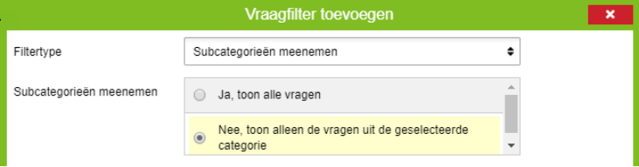

- Before, a negative score could be inserted in the answer option of a text entry question. This has been adjusted.

Student view

Exam performance
- It is shown clearer when no internet access is available on all pages that have to do with exam performance. Buttons that don’t work when there is no internet access are shown grey and notifications indicate that the exam cannot be continued until there is internet access.
- Calculator optimisations
  - The full stop was not recognised as a comma in the numeric part of the calculator.

Rounds of corrections and correcting answers

Menu ‘Results’ > ‘Correcting answers’
- Students could not view all of the casus text, when they were allowed to correct the open questions themselves. This option has been added.
- When the answer key for an open question is edited, it is clearer for the corrector to see which question is addressed. The question has the status ‘Vereist hercorrectie’ (not official translation: Answer must be checked again) and the scoring needs to be adjusted on the base of the edited answer key to be able to hand in the score results.
- The interface for re-using previous made comments by the corrector is improved:
  - When the comment exists of multiple loose sentences, they can be re-used apart from each other.
  - The comment list is sorted based on the amount of times the comment is used.
  - Comments of results that are not shown in the specific moment can be re-used.
- When results of previous anonymous rounds of corrections are shown, names of correctors are not shown anymore.

Results

Menu ‘Results’ > ‘All results’

- Both the established scores and the applied negate guessing are now shown in the mouse over.
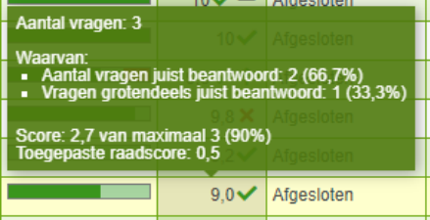

Menu ‘Results’ > ‘All results’ > ‘Details of the result’

- The representation of the scoring of a result is improved:
  - The components of an exam are shown in a table.
  - In the caesura explanation, the multiple areas of caesura settings are explained clearer.
  - In the case of a combined caesura, the scoring is described per feedback report.
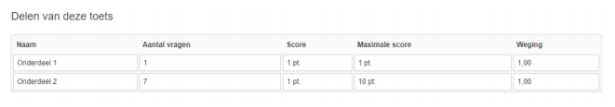

Analysis
Menu ‘Results’ > ‘Analysis’
- When editing the answer key of a text entry question, it is now possible to add a new option based on a list with all answers given by the candidates. Multiple answers can be added at once.

